**Expense Reimbursement System**

**Executive Summary**

The Expense Reimbursement System (ERS) will manage the process of reimbursing employees for expenses incurred while on company time. All employees in the company can login and submit requests for reimbursement and view their past tickets and pending requests. Finance managers can log in and view all reimbursement requests and past history for all employees in the company. Finance managers are authorized to approve and deny requests for expense reimbursement.

***Reimbursement Status State Flow Diagram***

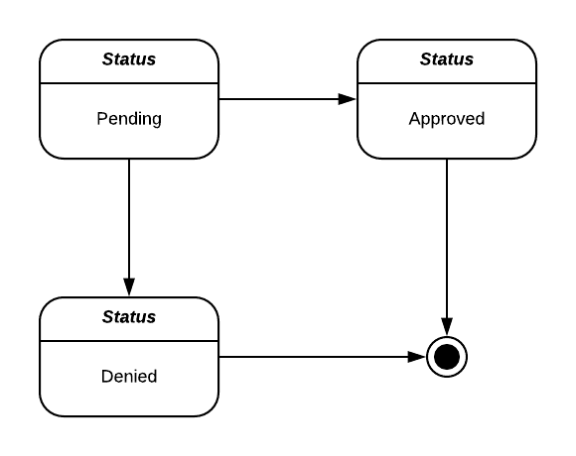

***Reimbursement Types***

Employees must select the type of reimbursement as:

* LODGING
* TRAVEL
* FOOD
* OTHER

***ERS Relational Model***

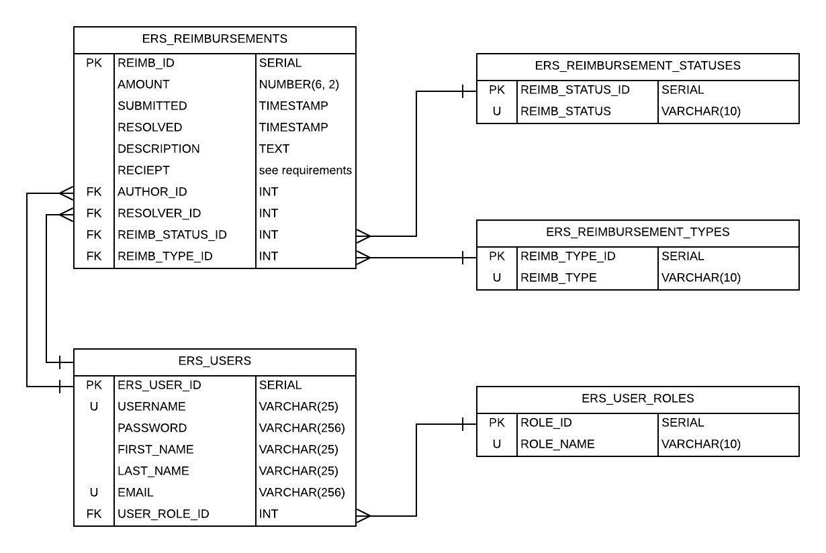

***Notes on the relational model***

* (OPTIONAL) The receipt images can either be stored in one of two ways:

1. As a BLOB data type within the database
2. As a link that points to the object stored in an AWS S3 bucket (properly secured)

* Passwords should be hashed before being stored within the database

***ERS Use Case Diagram***

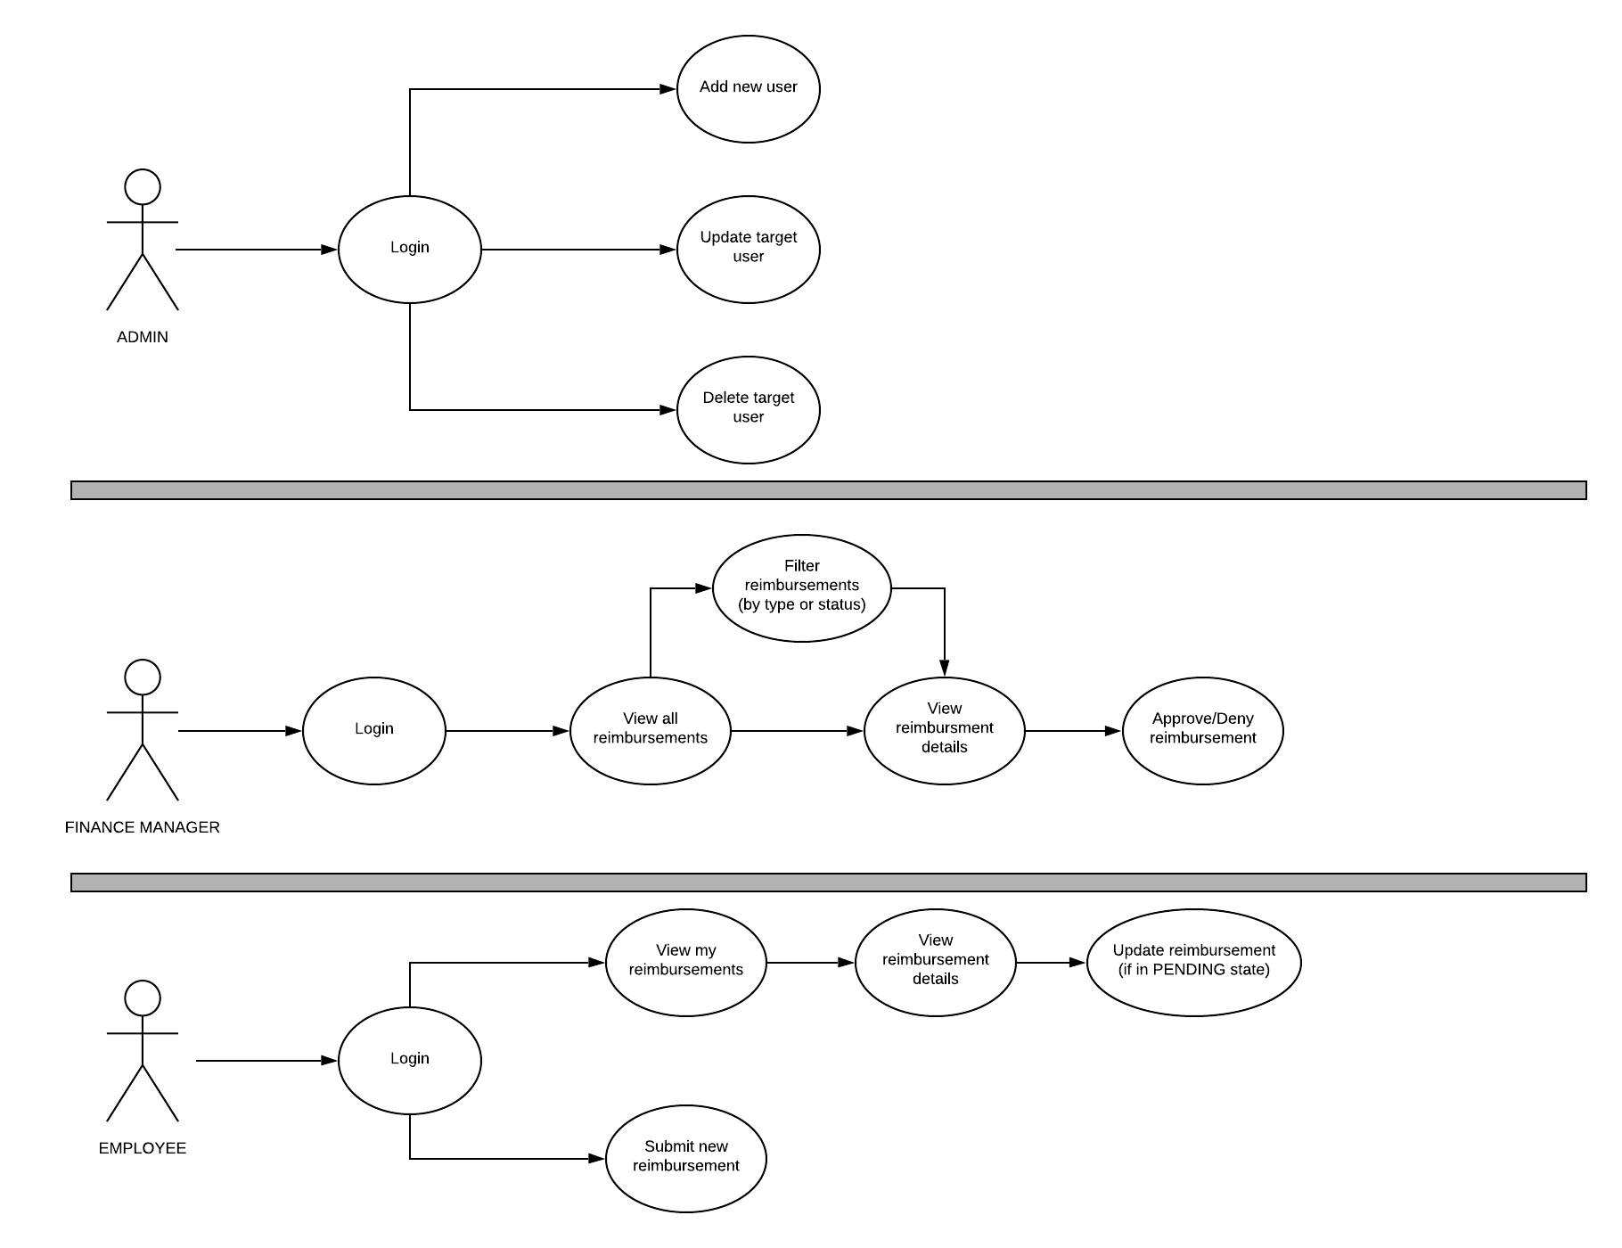

***Technical Requirements***

Persistence Tier

* PostGreSQL
* AWS Simple Storage Service (optional for receipt image storage)

Application Tier

* Language: Java 8
* Authentication Strategy: JWTs or HttpSession

***Non-Functional Requirements***

Persistence Tier

* Database is deployed to an AWS RDS instance
* The provided relational model is adhered to
* If AWS S3 is leverage the bucket must be properly secured

Application Tier

* API is deployed to an AWS EC2 instance (optional)
* All methods are properly documented
* Service layer of application has a minimum of 80% unit test coverage
* API leverages a general purpose logging framework (e.g. Log4J)
* All passwords are hashed before being stored in the data source

Operations Layer

* Development workflow will be augmented by a CI/CD pipeline using Jenkins or AWS CodePipeline, CodeBuild, and Elastic Beanstalk.